 

## DEPARTMENT OF ELECTRONICS AND COMMUNICATION ENGINEERING

LIBRARY MANAGEMENT SYSTEM

Submitted by

## KARTHICK C (927621BEC072)

## KARTHIKA R (927621BEC074)

## KEERTHANA D (927621BEC082)

## KEERTHI P (927621BEC085)

**Elite Training Project 1 Report**

**Java Programming**

Submission Date: **25/04/2023**

**Signature of Staff Incharge Signature of HOD**

**Signature of Elite Training Coordinator**

**Dr.D.Pradeep, ASP/CSE**

**SUMMARY**

**Screen Shots**

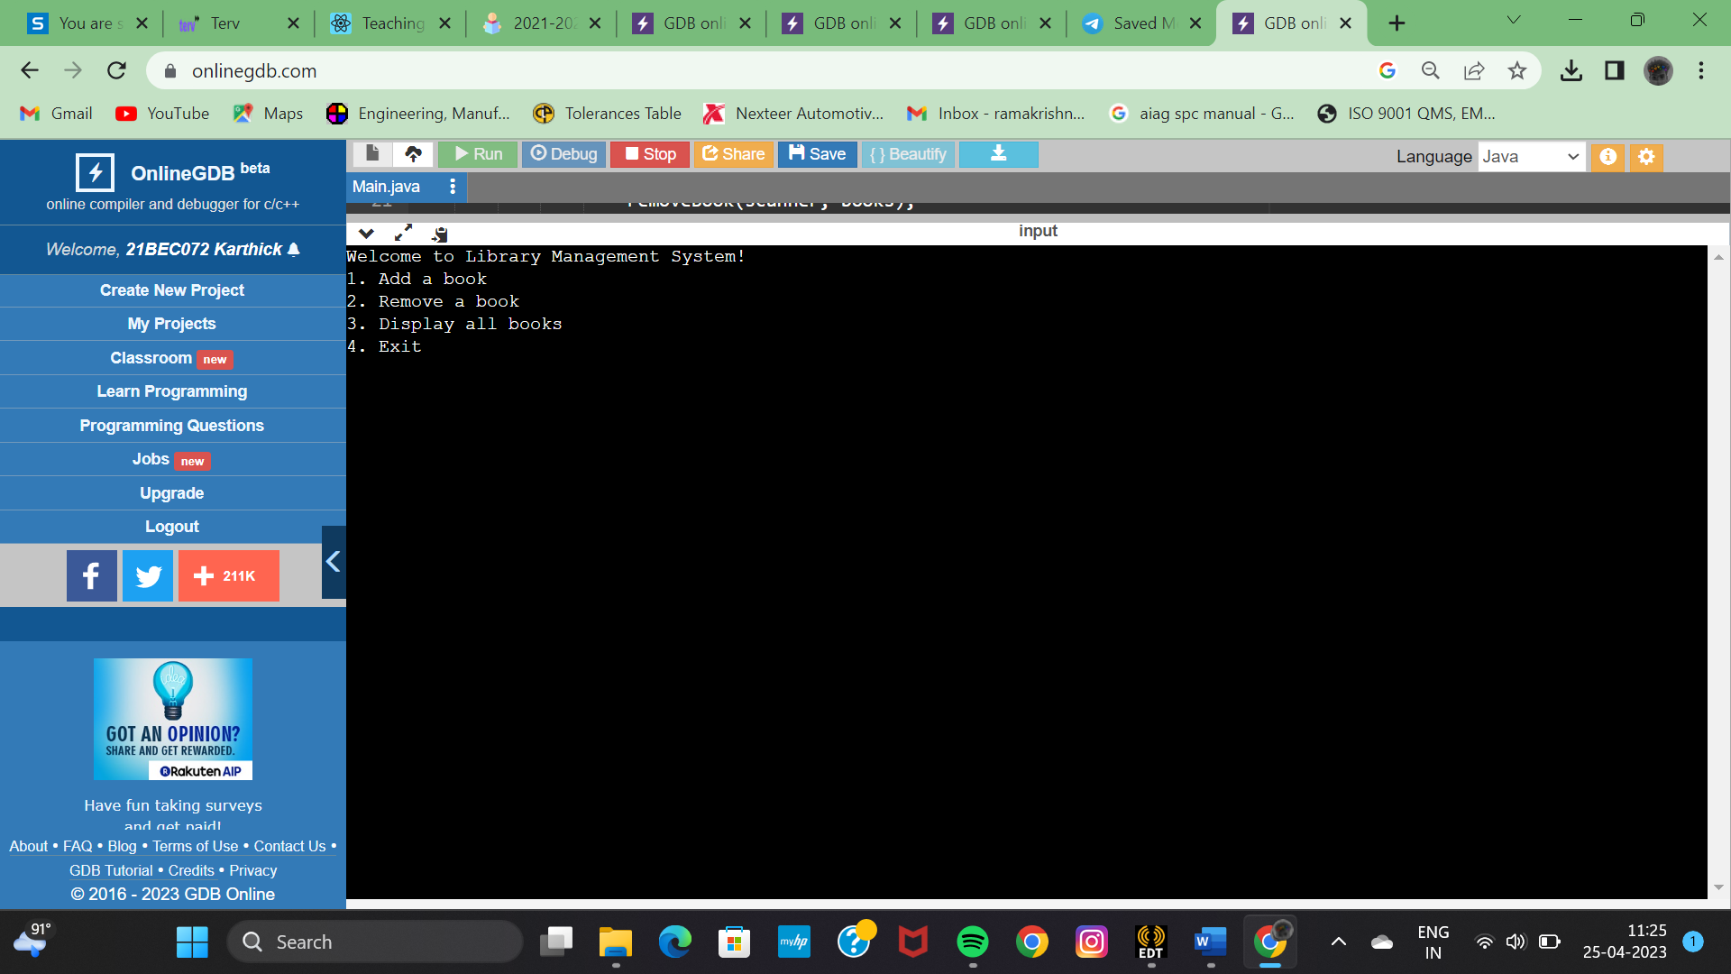

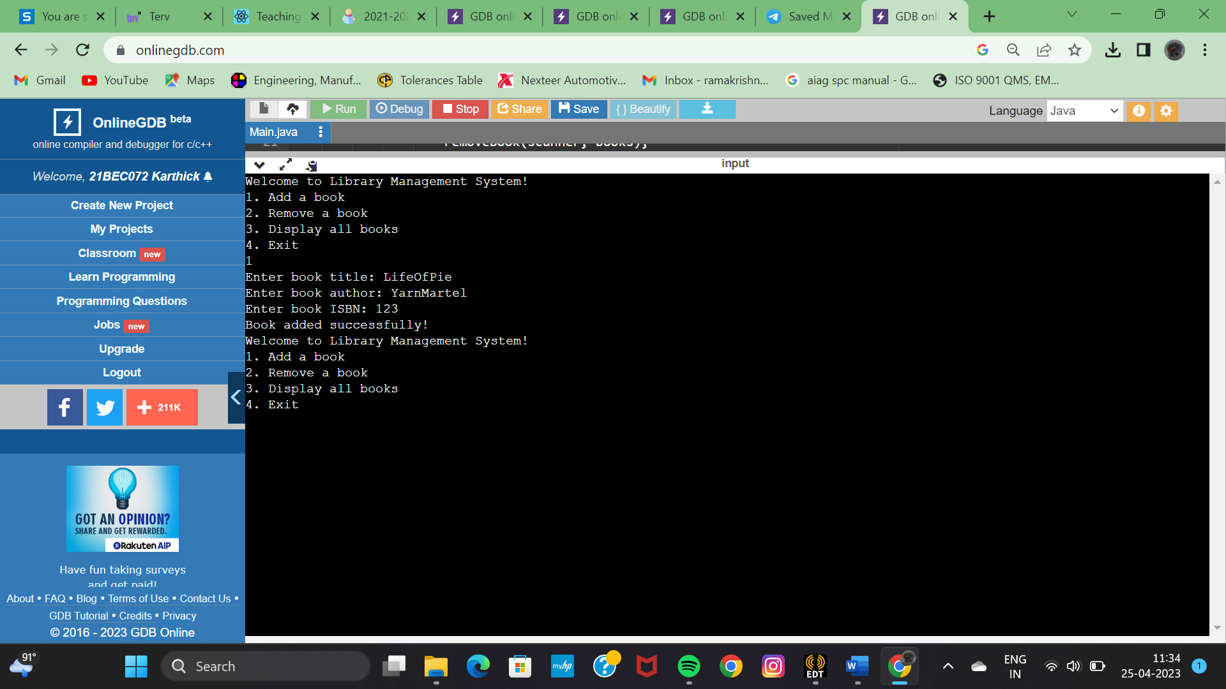

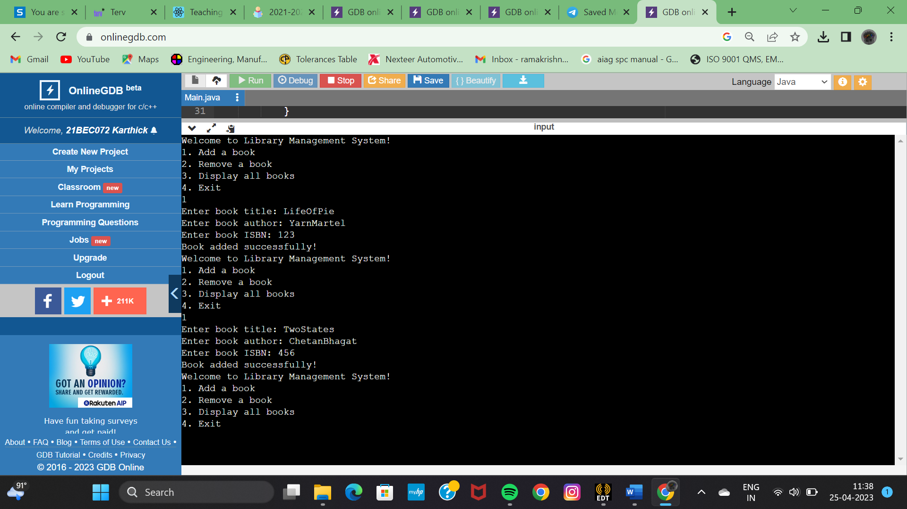

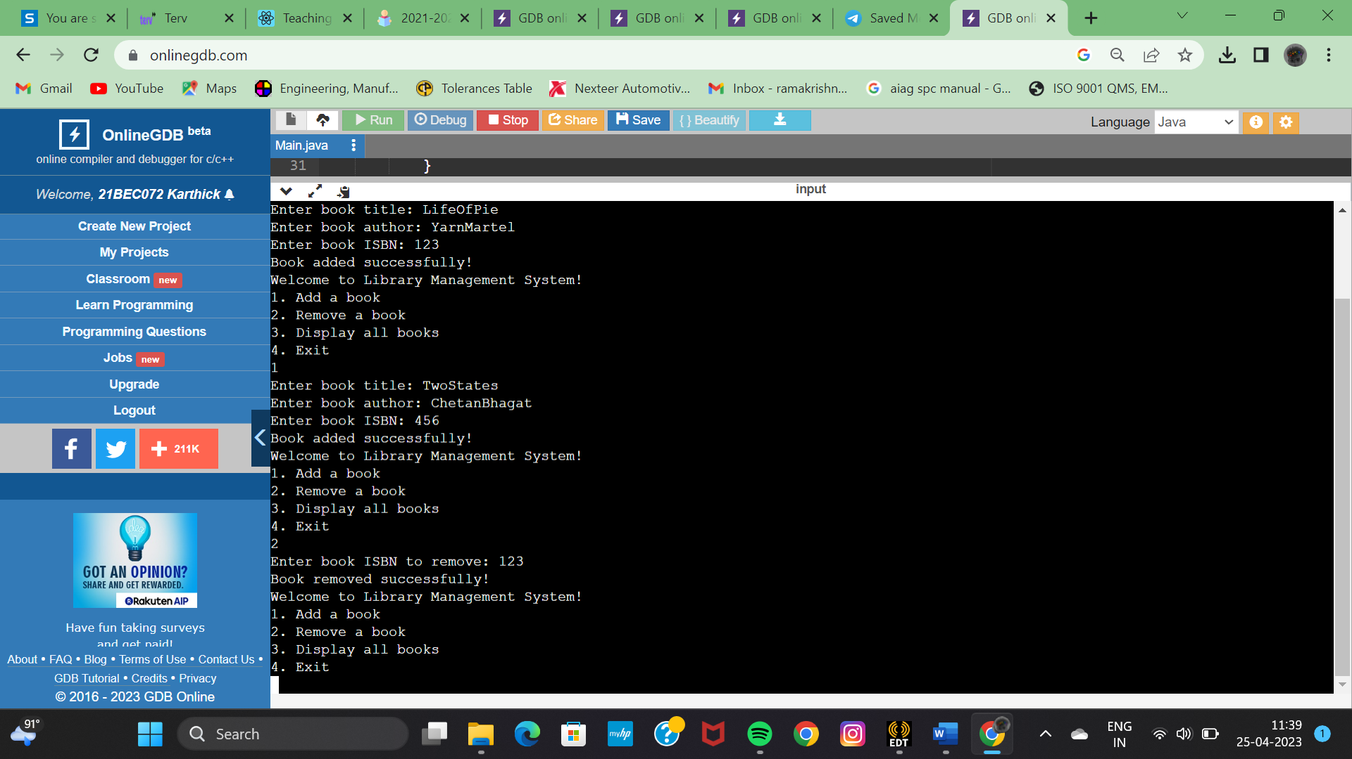

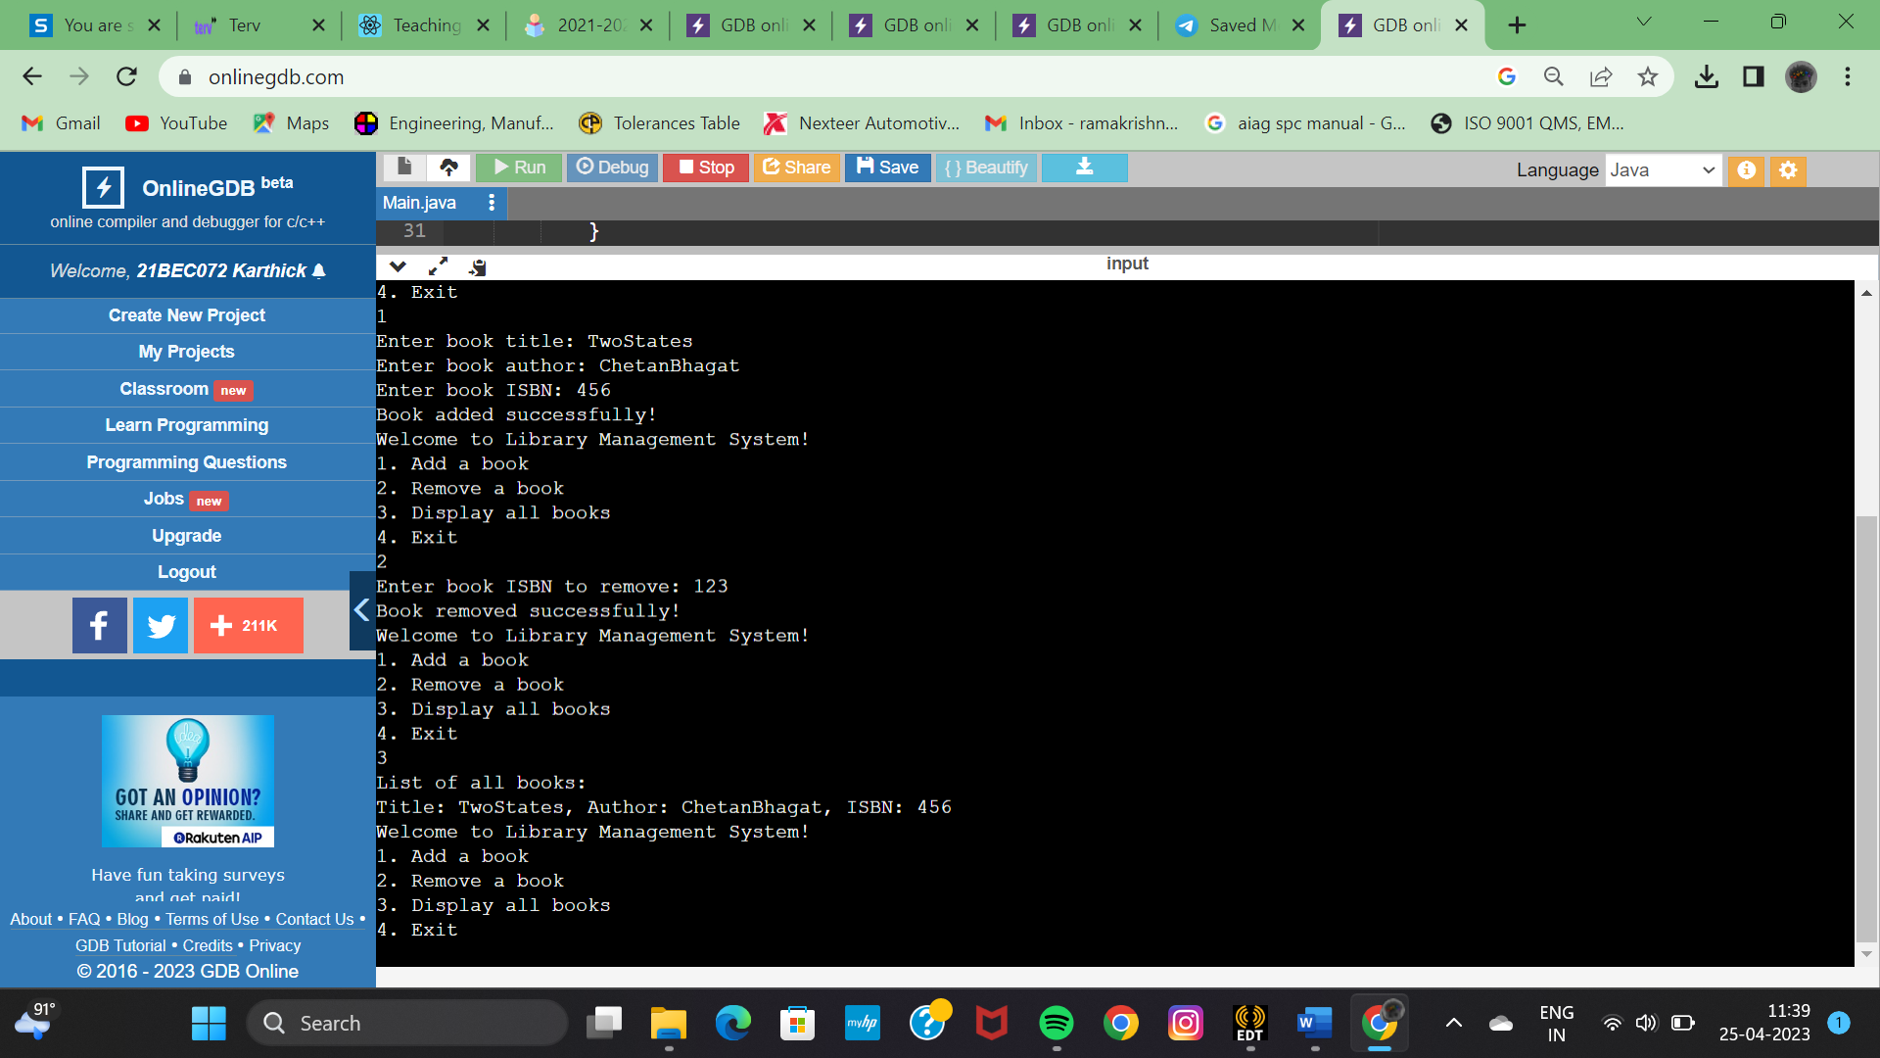

**SOURCE CODE:**

import java.util.ArrayList;  
import java.util.Scanner;  
  
public class LibraryManagementSystem {  
public static void main(String[] args) {  
Scanner scanner = new Scanner(System.in);  
ArrayList<Book> books = new ArrayList<>();  
  
while (true) {  
System.out.println("Welcome to Library Management System!");  
System.out.println("1. Add a book");  
System.out.println("2. Remove a book");  
System.out.println("3. Display all books");  
System.out.println("4. Exit");  
  
int choice = scanner.nextInt();  
switch (choice) {  
case 1:  
addBook(scanner, books);  
break;  
case 2:  
removeBook(scanner, books);  
break;  
case 3:  
displayBooks(books);  
break;  
case 4:  
System.out.println("Exiting Library Management System. Goodbye!");  
System.exit(0);  
default:  
System.out.println("Invalid choice! Please enter a valid choice.");  
}  
}  
}  
  
private static void addBook(Scanner scanner, ArrayList<Book> books) {  
System.out.print("Enter book title: ");  
String title = scanner.next();  
System.out.print("Enter book author: ");  
String author = scanner.next();  
System.out.print("Enter book ISBN: ");  
String isbn = scanner.next();  
  
Book book = new Book(title, author, isbn);  
books.add(book);  
System.out.println("Book added successfully!");  
}  
  
private static void removeBook(Scanner scanner, ArrayList<Book> books) {  
System.out.print("Enter book ISBN to remove: ");  
String isbn = scanner.next();  
  
boolean removed = false;  
for (Book book : books) {  
if (book.getIsbn().equals(isbn)) {  
books.remove(book);  
removed = true;  
break;  
}  
}  
  
if (removed) {  
System.out.println("Book removed successfully!");  
} else {  
System.out.println("Book not found! Please enter a valid ISBN.");  
}  
}  
  
private static void displayBooks(ArrayList<Book> books) {  
System.out.println("List of all books:");  
for (Book book : books) {  
System.out.println(book);  
}  
}  
}  
  
class Book {  
private String title;  
private String author;  
private String isbn;  
  
public Book(String title, String author, String isbn) {  
this.title = title;  
this.author = author;  
this.isbn = isbn;  
}  
  
public String getTitle() {  
return title;  
}  
  
public String getAuthor() {  
return author;  
}  
  
public String getIsbn() {  
return isbn;  
}  
  
@Override  
public String toString() {  
return "Title: " + title + ", Author: " + author + ", ISBN: " + isbn;  
}  
}